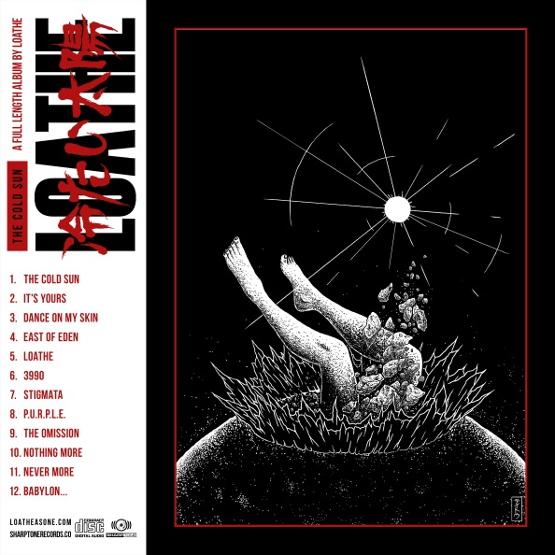

LOATHE
»The Cold Sun«

OUT: 14th April, 2017

Line-up:
Kadeem France // vocals  Erik Bickerstaffe // guitar & vocals  Shayne Smith // bass & vocals  Connor Sweeney // guitar & vocals  Sean Radcliffe // drums | Facebook - /loatheasone  Instagram - loatheasone  Twitter - @loatheasone
“We stand by the outlook that negativity can be channeled and used as a tool to create something not only positive but progressive“- Erik Bickerstaffe.
Is LOATHE’s Erik Bickerstaffe onto something? In these seemingly somber and tumultuous times, we can either stand by and watch the world burn; or we can try channel the negative stream into something meaningful and erudite. LOATHE are a sedulous collective of 5, formed in the UK‘s industrial and artistically acclaimed port-city, Liverpool. Their debut record »The Cold Sun« signifies a forceful and shrewd testimony. The quintet nail their colors to the mast with this resolute mission statement; an ode to the times we’re living in and the murky future that we all find ourselves faced with.
"We all met through music in one form or another. When our previous projects became stagnant, it felt right that we should pool our ambition into what is now LOATHE," states Shayne Smith, when asked about the band’s genesis.
»The Cold Sun« is a concept record; a compelling 35 minute long meandering into the depths of a dark, post-apocalyptic tale. The record follows the adjacent timeline of two protagonists (A & B), who exist during a dystopian future, stricken by tragedy and the ever looming apocalypse.
“Our writing process varies from song to song, but usually it takes one of us to have the initial vision for what we want to create. We then each add our own personal input which completes the piece“, states Smith, when asked about the quintet’s approach to their craft.
“We approached the record with a specific sound in mind. Combining loose and real instrumentation with technical electronic elements, we created a soundscape that accompanies and represents the overall feel of »The Cold Sun«“, added Bickerstaffe.
“To help give a hint as to our trajectory of thought; 'Dance On My Skin' follows character A's experience with sleep paralysis as they are tormented during a night terror...“
To bring this intricate manuscript to fruition, LOATHE travelled to Glow In The Dark Studios in Atlanta, Georgia to record »The Cold Sun« under the watchful eye of producer Matt McClellan (UNDEROATH, THE DEVIL WEARS PRADA, BEING AS AN OCEAN...).
“Glow In The Dark has produced some of our favorite records and it was humbling to be a part of its legacy“, states Bickerstaffe. “From the bands inception we had planned to work with Matt McClellan, although it was only until after signing to SharpTone Records that we had the opportunity to make it happen. We felt like Matt‘s approach would aid us in defining our sound for the record. We experimented with our usual approach to writing during our time at Glow In The Dark, and we’re very proud to present this as the outcome. “
»The Cold Sun« is a highly accomplished and enigmatic chronicle, an undoubtedly passionate oeuvre brimming with technical precision, sinister ambience and bitter bile. LOATHE offer a complex sonic architecture which weaves together post-punk, hardcore, heavy electronics, djent and deathcore with a side of prog... melding their sonic threads into an anguished and searingly surreal entity which reels you deep into the abyss.
»The Cold Sun« will be released on 14th April 2017 via SharpTone Records.

UK PRESS CONTACT: claire@sharptonerecords.co

